# Local Provider

## Objectives

1. Create a file in any folder in your system (C:\temp\1.txt) with content Hello this is from terraform

# Azure Provider

## Objectives

* Create a vnet with 6 subnets and explain the concept of count, Infra as Code

# AWS Provider

## Objectives

* Create a vpc with 6 subnets and explain the concept of count, Infra as Code

# Linux Shell Scripting

Doc: <https://directdevops.blog/2020/08/14/linux-classroom-series-13-aug-2020/>

Video: [Linux Tutorial | Shell Scripting | Linux Classroom Session 24](https://www.youtube.com/watch?v=3U7zH27lQ5s&list=PLuVH8Jaq3mLtx82QrxoUre38AqJQwQ3bs&index=24)

[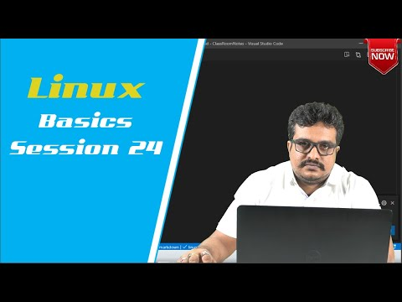](https://www.youtube.com/watch?v=3U7zH27lQ5s&list=PLuVH8Jaq3mLtx82QrxoUre38AqJQwQ3bs&index=24)